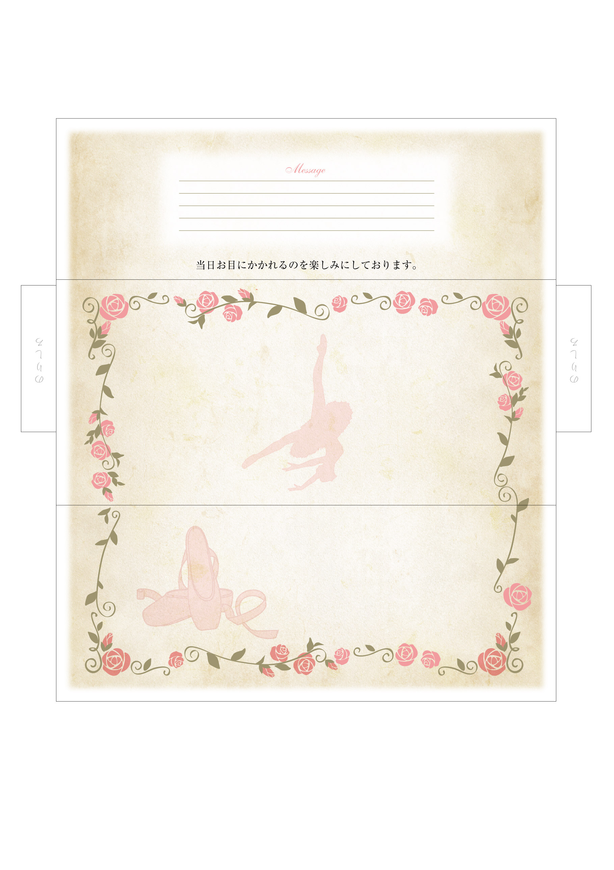

*Ballet recital of*

*the Narimasu Balletschool.*

*Narimasu*

*Ballet Scool*