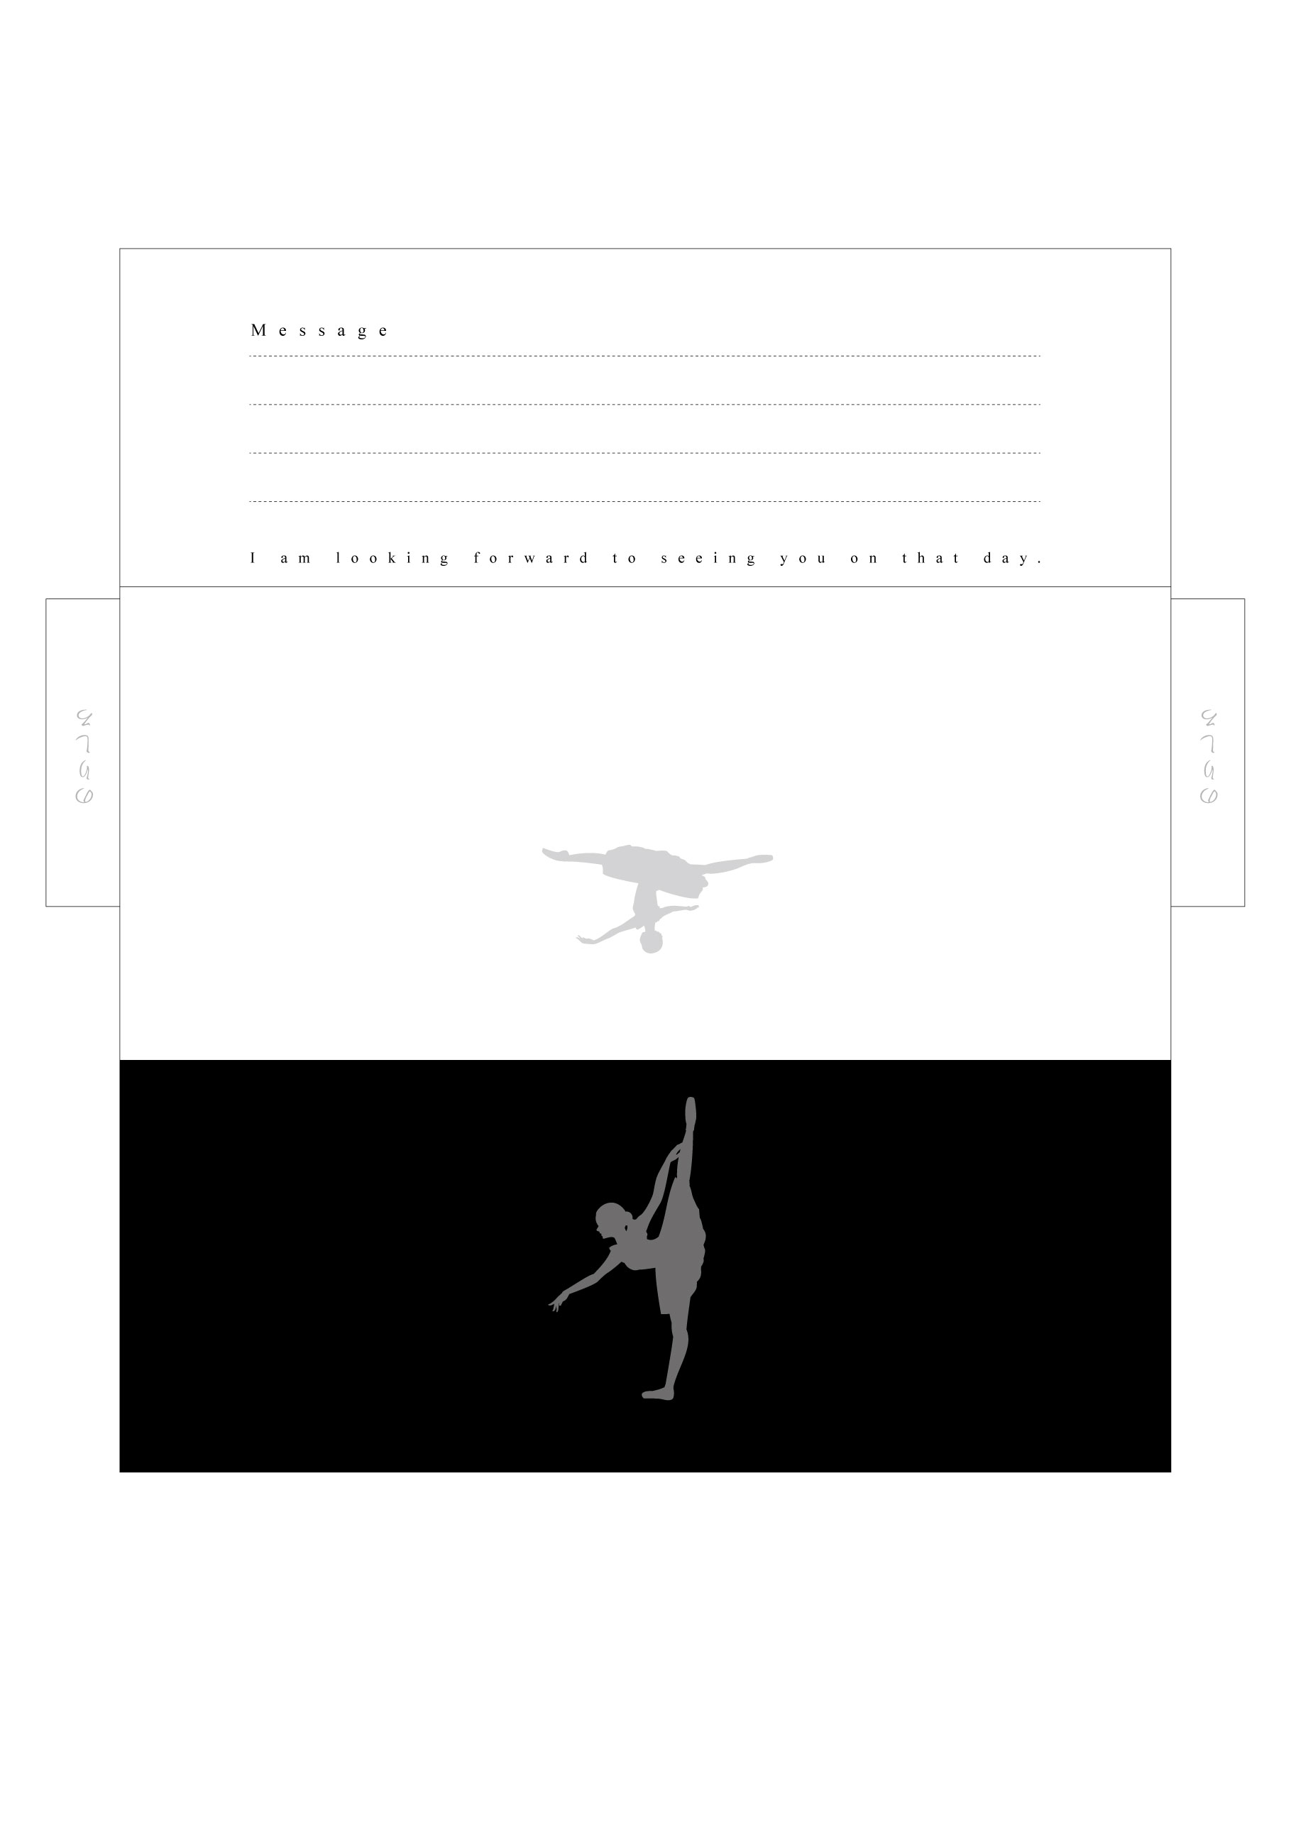

NARIMASU BALLET SCHOOL

NARIMASU BALLET SCHOOL