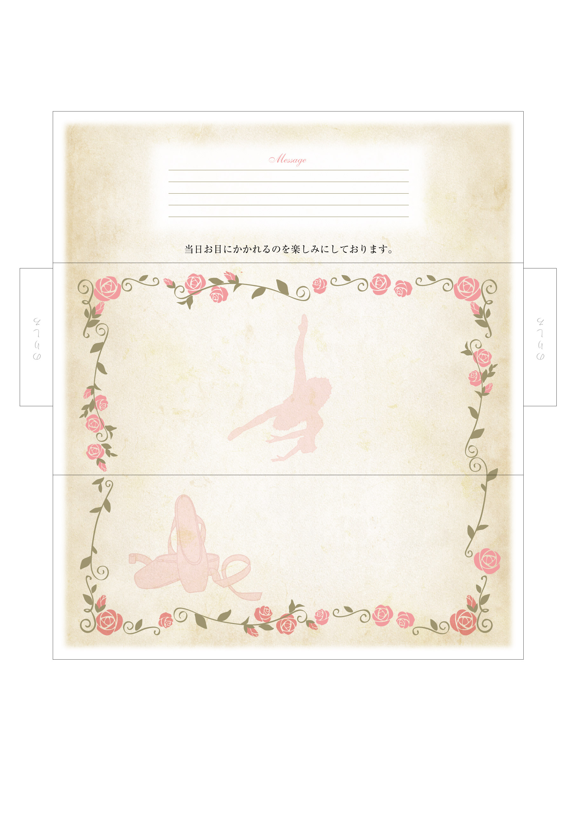
Ballet recital of
the Narimasu Balletschool.
Narimasu
Ballet Scool

