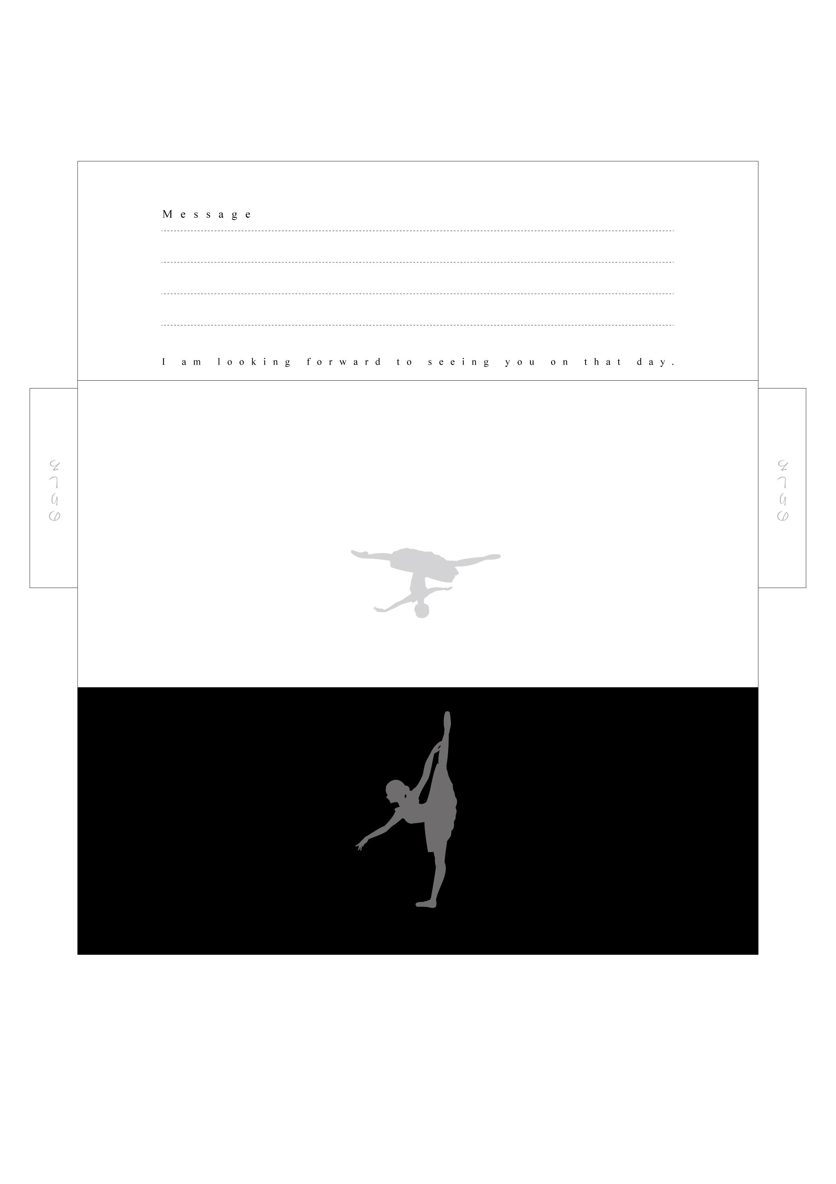
NARIMASU BALLET SCHOOL
NARIMASU BALLET SCHOOL

