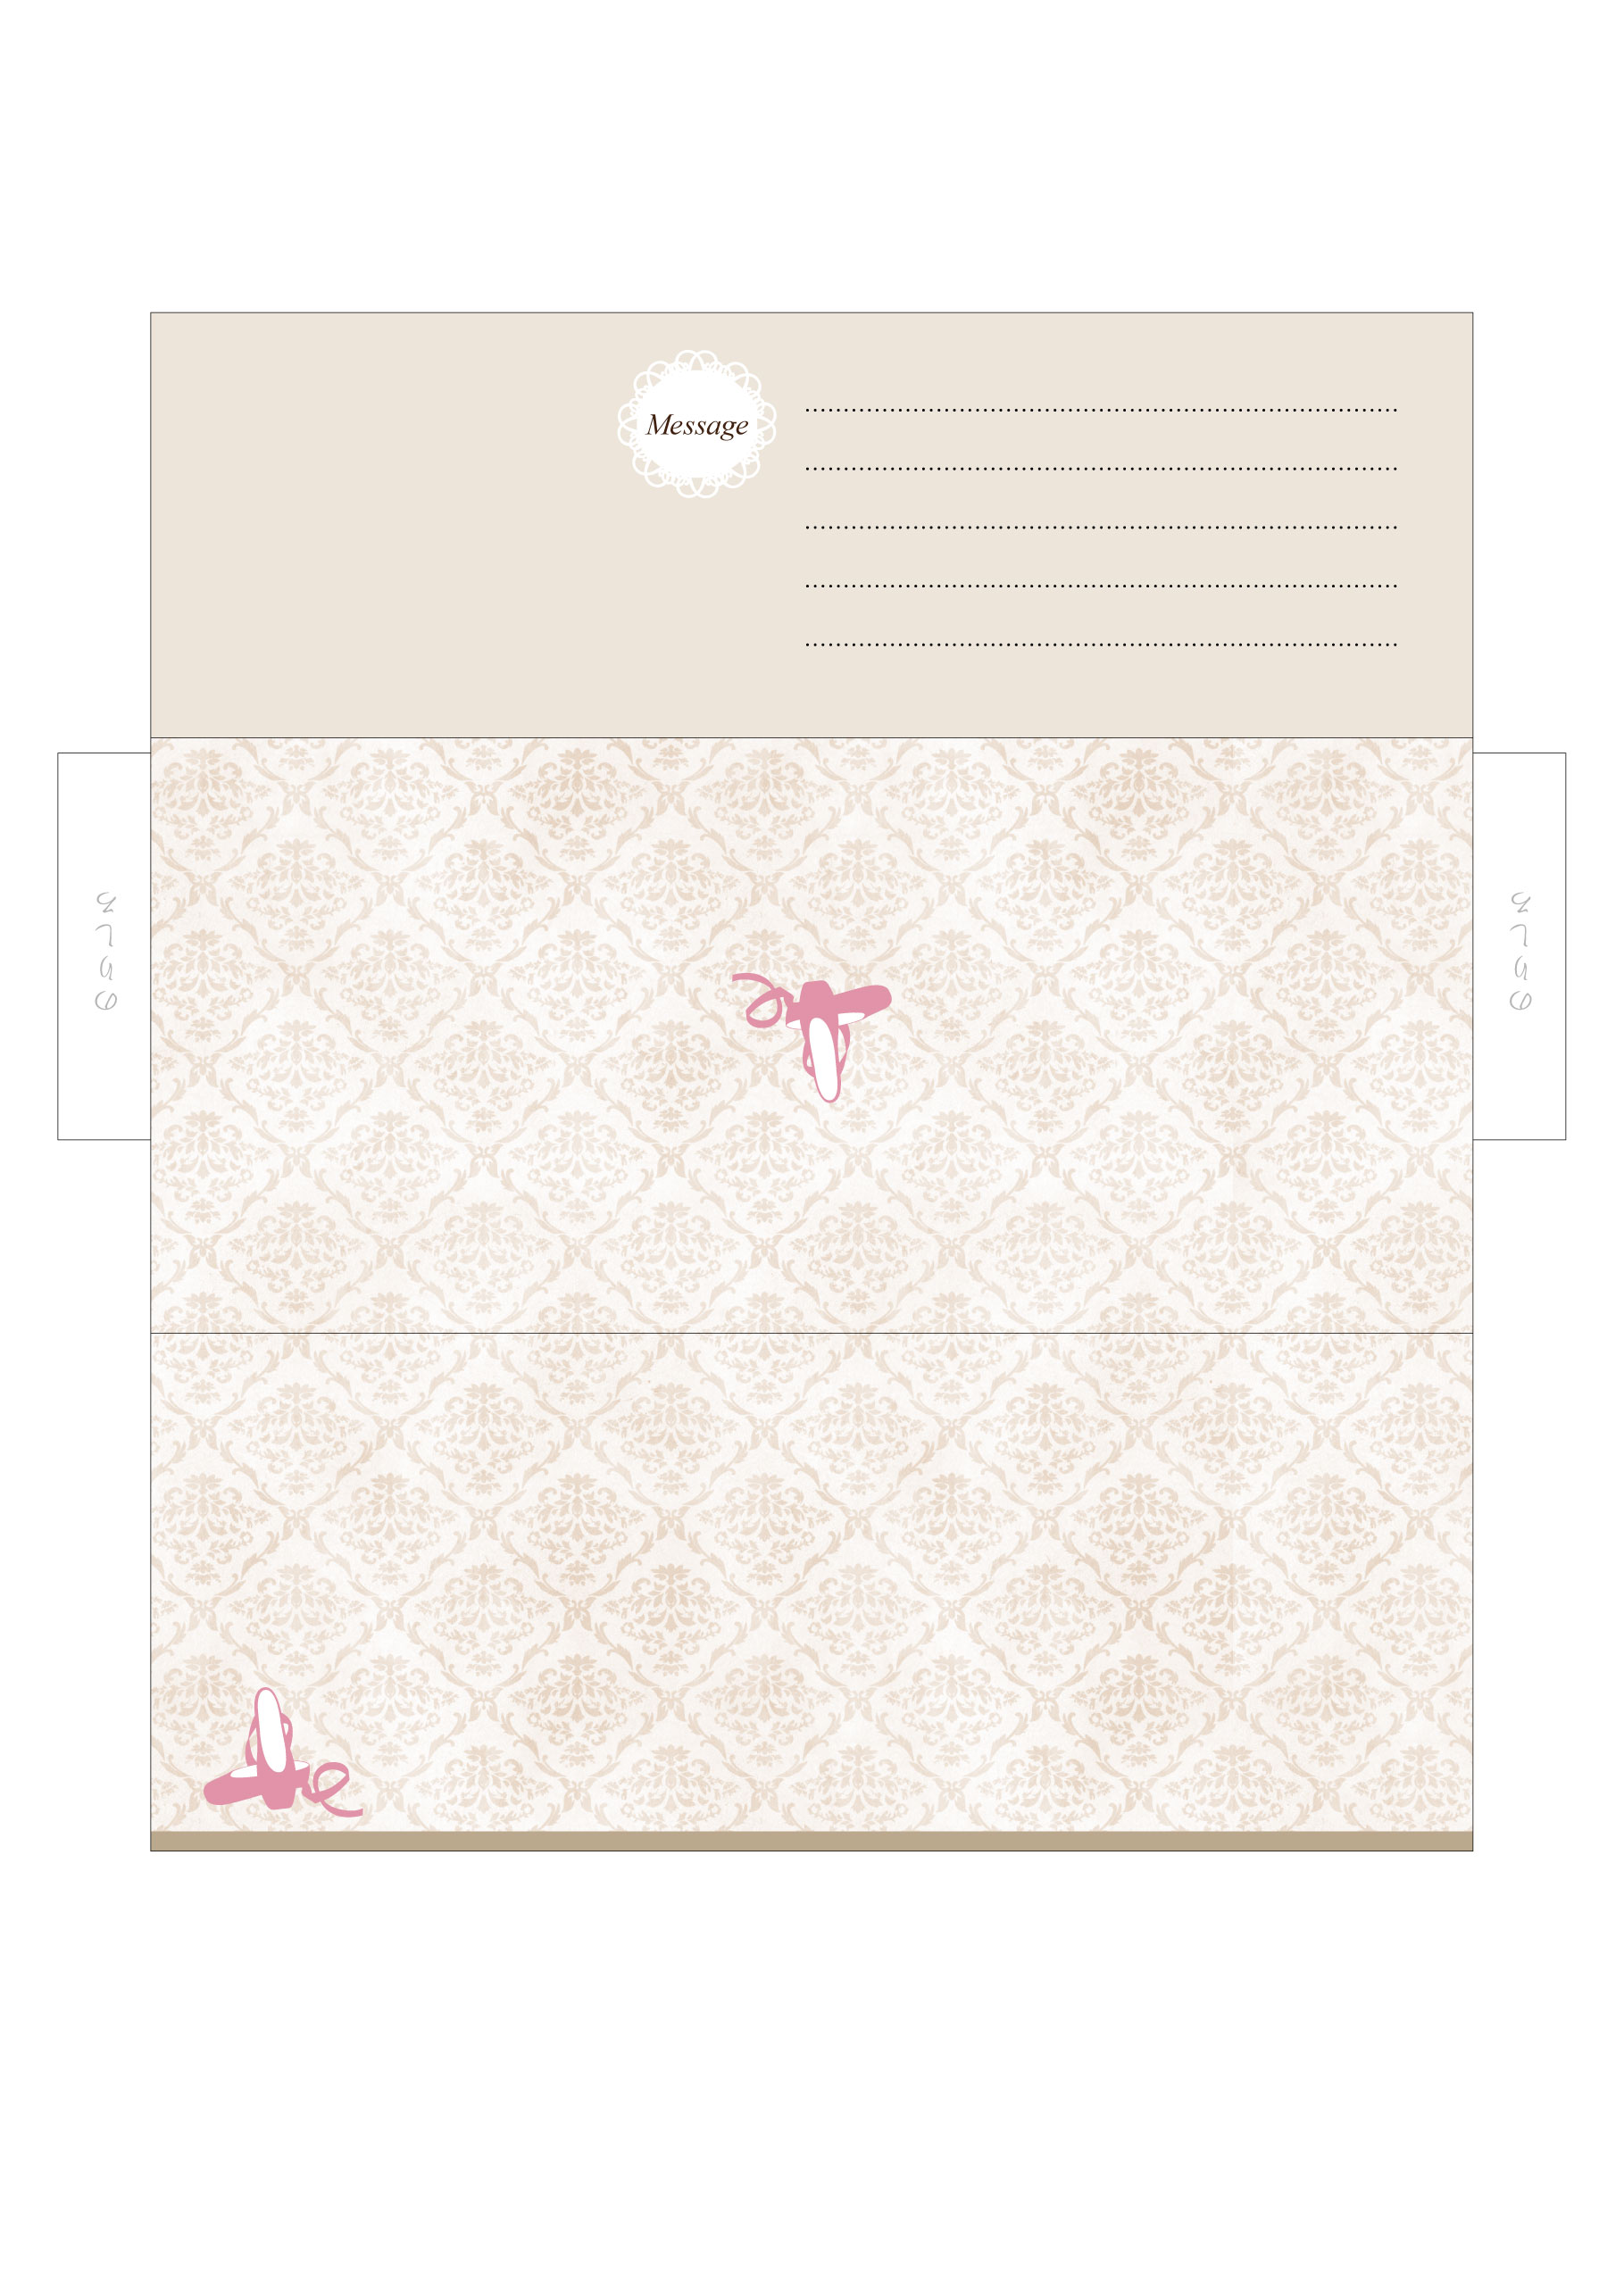
Narimasu Ballet School
Narimasu Ballet School

