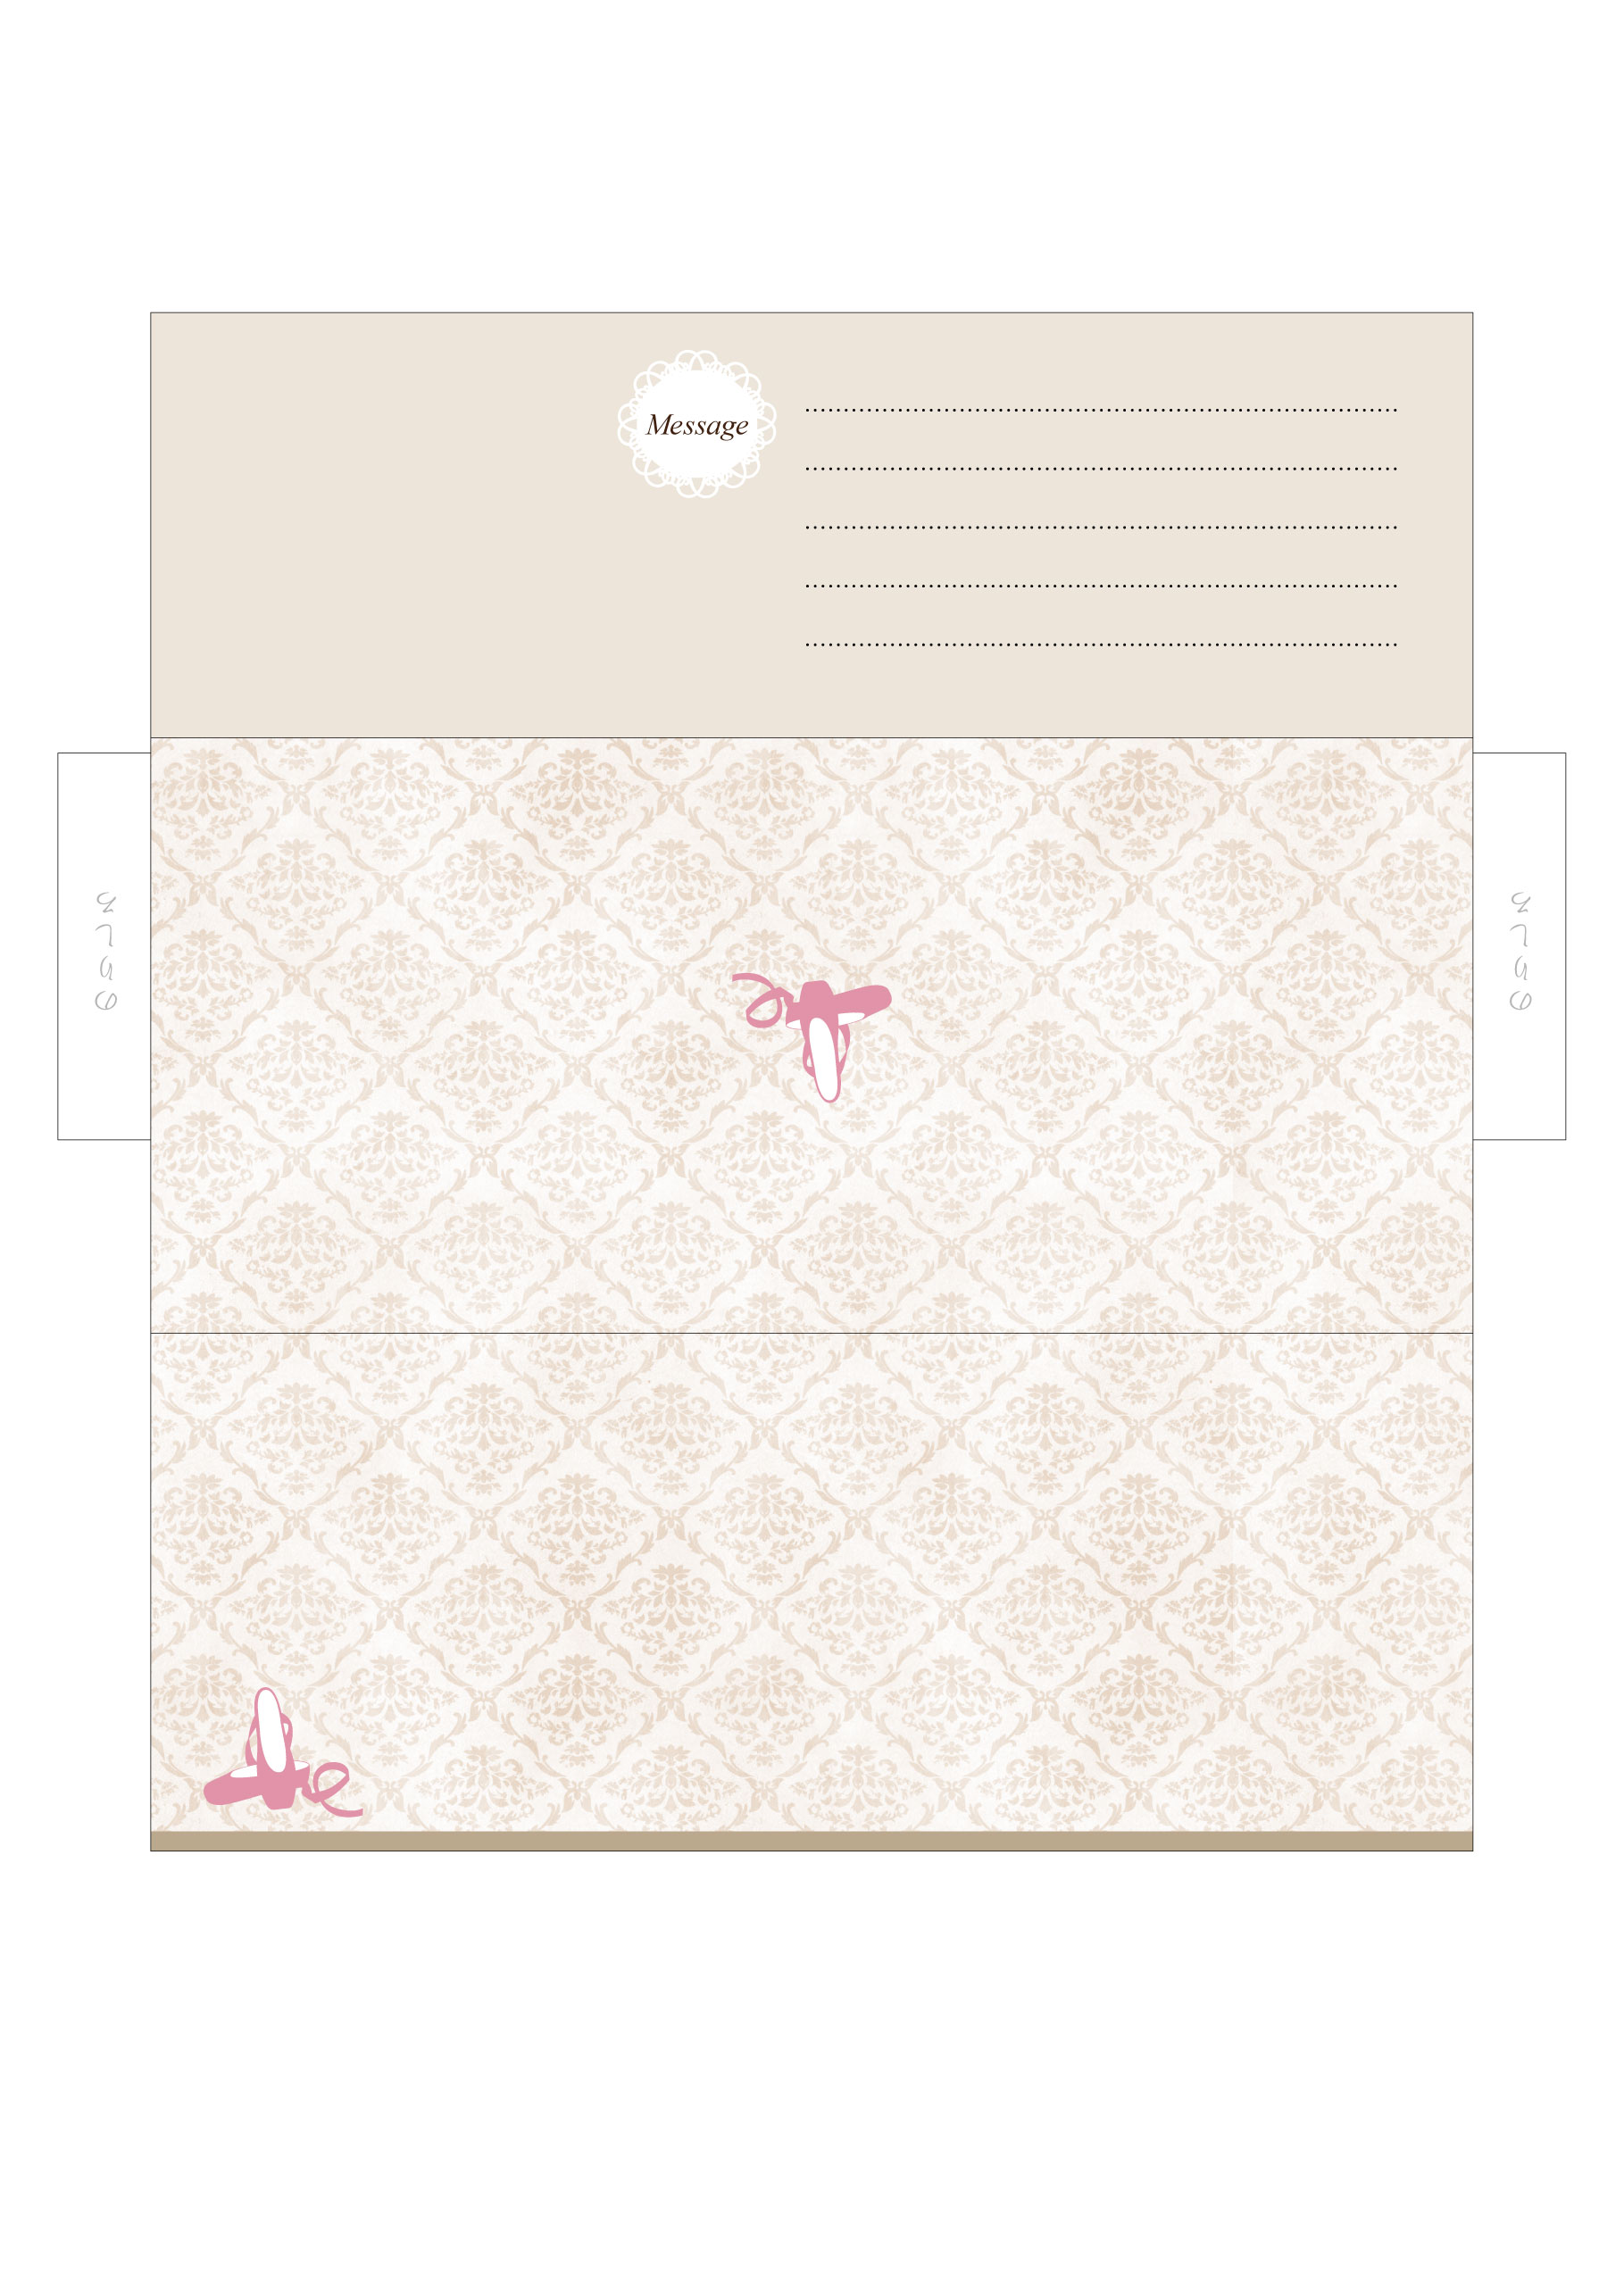

*Narimasu Ballet School*

*Narimasu Ballet School*